

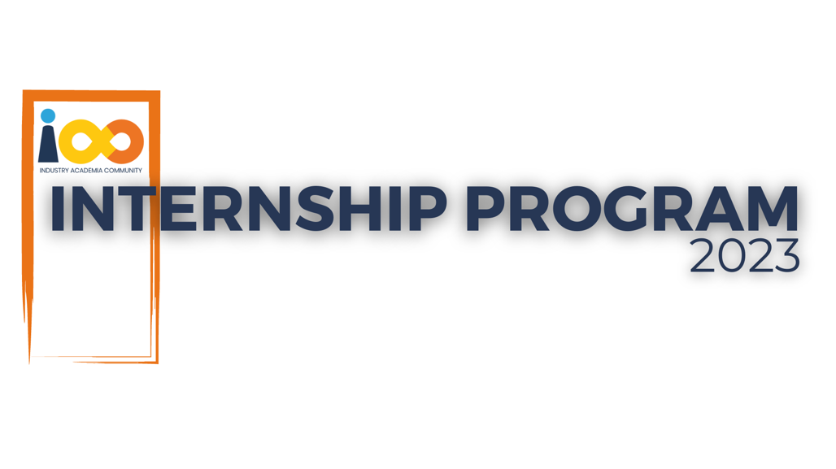

PROJECT REPORT

Data Analytics  
  
Student Insights : A Power BI Approach

|  |  |  |  |
| --- | --- | --- | --- |
| **Created By:** | Vaishnavi Umate | **Approved By:** | Harshada Topale |
| **Created On:** | 6-12-2024 | **Approved On:** | 6-12-2024 |

Page left blank intentionally

**INDEX**

**1** **PROJECT DETAILS** 2

**2** **SUMMARY** 2

**3** **INTRODUCTION** 2

3.1 Background 2

3.2 Stakeholders 2

3.3 Objectives 2

**4** **METHODOLOGY** 2

4.1 Considerations & Assumption 3

4.2 Approach 3

4.3 Activities 3

**5** **TARGETTED V/S ACHIEVED OUTPUT** 3

**6** **CONCLUSION** 3

**7** **APPENDICES** 4

7.1 Appendix A – Title 4

# **PROJECT DETAILS**

|  |  |  |  |
| --- | --- | --- | --- |
| **Project Name** | Student Insights : A Power BI Approach | | |
| **Project Sponsor** | Harshada Topale | | |
| **Project Manager** | Harshada Topale | | |
| **Start Date** | 6/12/2024 | **Completion Date** | 6/12/2024 |

# **SUMMARY**

This project was needed to gain a deeper understanding of the factors influencing student outcomes, such as academic performance and expected salary. By analysing this data, educational institutions, policymakers, and stakeholders can make informed decisions to improve student support services, curriculum design, and career counselling. Understanding these factors can also help in identifying areas where students may need additional resources or support to achieve better outcomes.

# **INTRODUCTION**

## Background

This project aims to analyse a comprehensive dataset of students, providing insights into various factors affecting their academic performance and career expectations. The dataset includes attributes such as GPA, family income, experience with Python programming, expected salary, and more. Millions of students apply for internship/job every year, resumes play an important role in playing first impression. The recruiters spend max of 2-3 minutes reviewing a resume after it landed in their mailbox or job board, ATS application. Surprising more than 70% of resumes get rejected in the initial stage.

## Stakeholders

The primary problem this project aims to address is the lack of comprehensive insights into the factors affecting student performance and career outcomes. Educational institutions often struggle to identify the key determinants of academic success and career readiness among their students. This project seeks to bridge this gap by analyzing a detailed dataset of student attributes and providing actionable insights.

## Objectives

The objective of this project is to utilize Power BI to analyze and visualize a dataset of student information, including demographics, academic performance, graduation details, family income, and programming experience. The project aims to uncover insights such as the distribution of students across various categories, the relationship between family income and GPA, and variations in expected salaries. Additionally, it will identify outliers in course completion and evaluate student participation in events, ultimately providing a comprehensive understanding of the factors influencing student success.

# **METHODOLOGY**

These conventions are all about the positions of line breaks, how many characters should go on a line, and everything in between.

## Considerations & Assumption

The project faced several constraints, including data availability limited to the provided dataset, which may not cover all potential factors influencing student outcomes. There were challenges related to data quality, such as incomplete or inconsistent data points, and technical limitations of Power BI in handling large datasets efficiently. Additionally, the project was bound by a strict timeframe and resource constraints, limiting the extent of analysis and refinement. These constraints required careful planning and prioritization to ensure the project objectives were met within the given limitations.

Challenges encountered during the project included data cleaning and preparation, such as handling missing values and standardizing data formats. Statistical analysis posed difficulties in identifying and managing outliers and selecting appropriate methods to analyze relationships between variables. Visualization challenges involved creating clear, intuitive, and interactive visual representations of the data to provide meaningful insights to stakeholders. Interpreting complex data findings and ensuring effective communication with stakeholders to incorporate their feedback were also significant challenges.

Assumptions were made to facilitate the analysis, including assuming the dataset's accuracy and completeness, representativeness of the broader student population, and consistency of variables. Technical feasibility assumptions were made about Power BI's capabilities and the project team's expertise in using it. Stakeholder engagement assumptions were necessary to ensure timely feedback and guide the analysis process. These assumptions helped streamline the project timeline, focus resources on critical aspects, and generalize findings to provide broader recommendations. Despite the challenges and constraints, these assumptions enabled the project team to deliver valuable insights effectively.

## Approach

To solve the problem, we adopted a structured, data-driven approach. The process began with a comprehensive requirement-gathering phase to understand stakeholder needs and the scope of the analysis. We then cleaned and pre-processed the dataset to ensure accuracy and consistency. This was followed by exploratory data analysis (EDA) to identify key patterns and relationships within the data. Based on these insights, we developed a series of visualizations to effectively communicate findings. Finally, an interactive Power BI dashboard was created to enable stakeholders to explore the data dynamically. This structured approach ensured that the analysis was thorough, accurate, and aligned with stakeholder expectations.

## Activities

The project involved several key activities, starting with requirement gathering to understand the objectives and expectations of stakeholders. This was followed by data cleaning and preparation to ensure the dataset was accurate and consistent. We then conducted exploratory data analysis (EDA) to uncover key insights and patterns. Visualization development was the next step, creating intuitive charts and graphs to present the findings. Finally, we developed an interactive Power BI dashboard to allow stakeholders to explore the data and insights dynamically. Each activity was crucial in ensuring the project's success and delivering valuable insights to the stakeholders.

# **TARGETTED V/S ACHIEVED OUTPUT**

The targeted output of the project, as outlined in the project plan, included a comprehensive dataset analysis, insightful visualizations, and an interactive Power BI dashboard. We successfully achieved these goals by providing a detailed analysis of student attributes, creating visualizations to display the distribution of students and the relationship between various factors, and developing a dynamic dashboard for stakeholder use. While there were minor deviations, such as handling unforeseen data quality issues and adjusting visualization formats based on stakeholder feedback, these adjustments ultimately enhanced the project's overall quality and relevance.

# **CONCLUSION**

The project has proven to be highly useful for stakeholders by providing deep insights into factors influencing student outcomes, such as GPA, family income, and programming experience. The interactive Power BI dashboard allows for ongoing exploration and analysis, aiding in informed decision-making and strategic planning. Future scope includes expanding the dataset to include more variables and longitudinal data, enhancing the dashboard with predictive analytics features, and integrating additional data sources to provide a more comprehensive analysis. This project sets a strong foundation for continuous improvement in understanding and supporting student success.

# **APPENDICES**

## Appendix A – Data Dictionary

